Omar Zaruk
Lindsey Meisch
Angelica Ramirez
Rishabh Patel

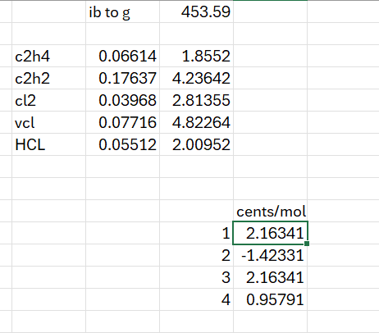

The preference in order is: 3 -> 1 -> 4 -> 2

